International Journal of Chemistry and Technology  http://dergipark.org.tr/ijct  Research Article | 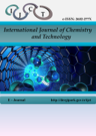

Virtual Screening and Molecular Docking of Natural Compounds as Selective Inhibitors of Mutant NRAS in Melanoma.
Nayanika DAS¹, Vijay BALADHYE¹*

¹ Bioinformatics Centre, Savitribai Phule Pune University, Pune 411007 (MS), India.

*Corresponding author : vijaybaladhye@gmail.com

------------------------------------------------------------------------------------------------------------------------------------------------------------------------------------------------

ABSTRACT

Melanoma is an aggressive and currently incurable skin cancer, primarily affecting individuals with light skin pigmentation. Key oncogenic drivers include mutations in BRAF, NRAS, CDK4 and MITF, with signaling mediated mainly through the MAPK and PI3K–Akt pathways. MEK inhibitors have shown limited clinical success, emphasizing the need for novel therapeutic agents. In this study, structure-based virtual screening and molecular docking were employed to identify natural products that inhibit mutant NRAS. The crystal structure of wild-type NRAS was obtained from the Protein Data Bank and clinically relevant mutations (Gly12, Gly13, Gln61) were introduced computationally. A library of natural compounds from the ZINC database was screened, identifying candidates based on binding free energy. Eleven top-ranking compounds were further analyzed for binding interactions, revealing stabilizing hydrogen bonds and hydrophobic contacts, particularly involving residues Phe28 and Asp119. These compounds exhibited strong predicted affinity for the NRAS mutant binding site, representing promising scaffolds for further development. The results demonstrate the utility of computational approaches to accelerate early-stage drug discovery targeting oncogenic NRAS in melanoma.

Keywords: NRAS, melanoma, molecular docking, MEK inhibitor, natural compounds etc.

------------------------------------------------------------------------------------------------------------------------------------------------------------------------------------------------

1. INTRODUCTION

Melanoma is a serious type of skin cancer that causes the most deaths worldwide. Melanocytes, found at the base of the epidermis, produce the UV-absorbing pigment melanin (Cancer.Net Editorial Board, 2025). Several environmental and genetic factors contribute to melanoma; most cases arise from mutations that occur later in life (National Cancer Institute, 2025; Cancer Genome Atlas Network, 2015). Key molecular drivers of melanoma include mutations in the RAS family of small GTPases (Al Mahi & Ablain, 2022). RAS family proteins are crucial for various cellular processes like signaling, survival, cell death, and transporting materials within cells (Cherfils & Zeghouf, 2013; Hu & Martí, 2025; Ostrem & Shokat, 2016). They act like switches, toggling between active (GTP-bound) and inactive (GDP-bound) states. This switching is mainly regulated by two flexible regions called Switch I (residues ~30–38) and Switch II (residues ~59–67) (Hu & Martí, 2025; Kolch et al., 2023; Li & Zhang, 2004; Spoerner et al., 2010; Vetter & Wittinghofer, 2001). When active, they can engage with effector proteins that manage essential biological functions like EGFR, MAPK, or PI3K (Ardito et al., 2012; Howe et al., 1992; Navas et al., 2012; Normanno et al., 2009; Rodriguez-Viciana et al., 1994; Wood et al., 1992). Excessive RAS activation can result in various cancers (Li et al., 2018; Moore et al., 2020). Most cancer-related mutations occur in residues G12, G13, and Q61, which are found in a region shared by HRAS, KRAS, and NRAS (Pylayeva-Gupta et al., 2011). Among these RAS isoforms, NRAS is particularly important in melanoma (Johnson & Puzanov, 2015; Wellbrock & Arozarena, 2016). Activating mutations in NRAS, especially at codon 61, are found in many melanoma cases and are closely linked to the activation of the MAPK signaling pathway (Johnson & Puzanov, 2015; Pylayeva-Gupta et al., 2011). Melanoma with NRAS mutations represents a unique and challenging subgroup in treatment (Johnson & Puzanov, 2015; Wellbrock & Arozarena, 2016), studies show that NRAS mutations tend to keep an active GTP-bound form (Li & Zhang, 2004; Vetter & Wittinghofer, 2001), the P-loop, also known as the Walker-A or G1 motif, is a glycine-rich region that binds to the β- and γ-phosphates of GDP/GTP and is highly conserved in Ras and other small GTPases (Vetter & Wittinghofer, 2001). Although some targeting strategies for KRAS (G12C) have recently been successful, similar methods for NRAS are still lacking (Moore et al., 2020; Ostrem & Shokat, 2016). Recent designs, like the potential inhibitor HM-387, aim to target the positively charged NRAS-Q61 mutant R61, pushing it into an “off-like” state. Thus, most current treatment approaches for NRAS mutant melanoma focus on indirect targeting of downstream signaling pathways (Johnson & Puzanov, 2015; Wellbrock & Arozarena, 2016). MEK inhibitors such as binimetinib and trametinib have shown some clinical effectiveness; however, response rates are still low and resistance often occurs (Johnson & Puzanov, 2015). Farnesyltransferase inhibitors and combination therapies have also been examined, but achieving long-lasting and specific inhibition of NRAS remains challenging (Moore et al., 2020). This highlights a pressing need for new methods to directly inhibit mutant NRAS. Natural products serve as a reliable yet underutilised source of bioactive compounds. Due to their structural diversity, complexity, and natural evolution for biological effects, natural compounds have significantly contributed to developing anticancer drugs (Harvey et al., 2015; Newman & Cragg, 2020). Notably, many approved anticancer treatments come from natural products or their derivatives, emphasizing their importance in drug discovery (Newman & Cragg, 2020). Computational methods based on structure offer an effective way to explore these options. Molecular docking and virtual screening allow for evaluation of how ligands bind (Kitchen et al., 2004; Lionta et al., 2014), and have been successfully applied in recent in-silico drug discovery studies for identifying bioactive compounds against therapeutic targets (Başar et al., 2024). These techniques are especially useful for targets like NRAS, where experimental data on ligand-bound structures is sparse. In this study, we used a structure-based computational approach to find natural compounds in the ZINC database with potential activity against relevant mutant NRAS variants (G12, G13, and Q61). We created and validated mutant protein models, followed by extensive virtual screening of natural compounds and molecular docking. We assessed candidate compounds based on predicted binding energy and detailed interaction analysis to identify the top molecules with stable hydrogen-bond and hydrophobic interactions with important functional residues in the NRAS active site.

2.1. Methods

2.1.1. Target identification

The KEGG database (Kanehisa & Goto, 2000) was used to study the melanoma pathway. Dysregulation of the MAPK pathway is very common in many cancers due to mutations in the RAS gene. The MAPK pathway is one of the major pathways involved in the progress of melanoma, and so it was chosen for this study. It harbours BRAF, NRAS, ERK, and MEK as its components. About 28% of the mutations are seen in NRAS of this pathway (Cancer.Net Editorial Board, 2025).

2.1.2. Protein Preparation

The wild-type NRAS structure with the best resolution and well curated in UniProt was selected. The PDB ID of this structure was 5UHV, and the UniProtKB ID was P01111. NRAS is a small GTPase structure. A clear difference between isoforms of NRAS is the binding of the Ras Binding Domain (Johnson et al., 2017). NRAS has only the A chain associated with it. Hence, docking was carried out on the A chain of NRAS at the active site. The G-domain, catalysing GTP hydrolysis and mediating downstream signalling, is 95% conserved between the Ras isoforms (Johnson et al., 2017). The wild-type NRAS has a total of 189 amino acids. The overall structure can be divided into a catalytic G domain, which is comprised of residues 1-86 and 87-166 (Johnson et al., 2017).

2.1.3. Protein Structure Validation

ProSA (Wiederstein & Sippl, 2007) is frequently used for protein structure validation. ProSA calculates an overall quality score for a specific input structure. The z-score indicates overall model quality (Wiederstein & Sippl, 2007). Its value is displayed in a plot showing the z-scores of all protein chains in the current PDB. ProSA (Wiederstein & Sippl, 2007) web visualises the 3D structure of the input protein using the molecule viewer Jmol. ProSA was used for validation of the structure of mutant NRAS built in SPDBV. PROCHECK (Laskowski et al., 1993), a model evaluation and validation tool, checks for the stereochemical quality of a protein structure, producing residue-by-residue geometry plots. It includes PROCHECK-NMR (Laskowski et al., 1993), for checking the quality of structures solved by NMR. The G-factor provides a measure of how normal or unusual the property is. It gives the Ramachandran plot to understand if the residues are in allowed or disallowed regions. PROCHECK was used for validation of the structure of mutant NRAS built in SPDBV (Laskowski et al., 1993).

2.1.4. Compound Library Curation and Filtering

The database used for obtaining natural compounds for screening was the ZINC Database (Irwin & Shoichet, 2005). Natural products occupy an important part of the small molecule space because they are recognised by at least two proteins: the end of their biosynthetic pathway and their evolutionary biological target. The natural compounds screened were obtained from the ZINC natural product library (Irwin & Shoichet, 2005). FAF-Drugs4 (Lagorce et al., 2017) is a program for filtering large compound libraries prior to in silico screening or related modelling studies. The tool can perform computational prediction of some ADME-Tox properties (adsorption, distribution, metabolism, excretion, and toxicity) to assist hit selection before chemical synthesis (Lagorce et al., 2017). This tool was used to filter out compounds in the ZINC database to remove interfering compounds and retain lead compounds with comparatively small log P for further optimisation. PAINS moieties, or Pan Assay Interference Compounds, are compounds that occur frequently in biochemical high throughput screens.

2.1.5. Virtual Screening and Molecular Docking

PyRx (Dallakyan & Olson, 2015) is a virtual screening tool used for docking natural compounds. It uses the AutoDock 4.2 suite (Morris et al., 2009) with Lamarckian genetic algorithm. The tool was first evaluated using the NRAS mutant structure and the ligand phosphoaminophosphonic acid-guanylate ester, a non-hydrolyzable analog of GTP. The nucleotide is a potent stimulator of adenylate cyclase and was docked. The RMSD tolerance of 2.0 Å indicated good software stability. The grid box was set to 50 × 50 × 50 with a spacing of 0.3750 Å. All ligands were converted to pdbqt format in PyRx. AutoDock was set to run generating 10 poses per compound. Only the pose with the best binding score was tabulated in the sdf files. This yielded the best protein-ligand binding candidates for further analysis. Docking results were analysed using LigPlot (Laskowski & Swindells, 2011), an advanced version of LigPlot for automatic generation of 2D ligand-protein interaction diagrams. The hydrophobic and hydrogen bond interactions contribute to protein-ligand complex stability and help determine the inhibitory potential of each compound on mutant NRAS.

3. RESULTS and DISCUSSION

3.1. Validation of mutant NRAS models

The mutant NRAS variants (G12D, G13D, and Q61R) were generated using SwissPDB Viewer based on the wild-type structural template. Structural quality checks confirmed the reliability of these models. The protein model's backbone torsion angles (phi and psi) are highly stereo chemically favourable, with over 90% of residues falling in the most allowed regions of the Ramachandran plot (Figure 1E–F), signifying excellent structural quality. Only a minor fraction occupied disallowed regions. ProSA scores were negative, indicating minimal erroneous regions (Figure 1C) were consistent with native proteins of similar size, indicating reliable global folding (Wiederstein & Sippl, 2007). The modelled NRAS mutant structure was therefore used for further analysis, demonstrating strong structural stability.
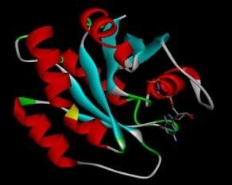
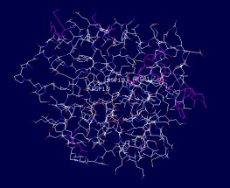

- (B)
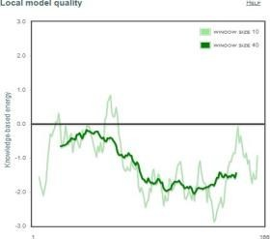
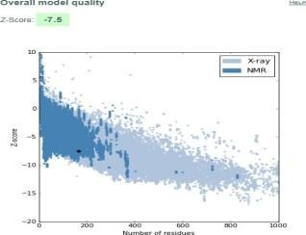

(C) (D)

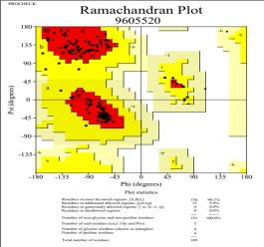
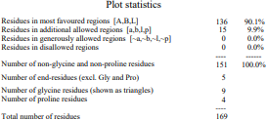

(E) (F)

Figure 1. (A) Protein showing secondary structure elements and residue connectivity. (B) Cartoon representation of the protein and coloured by secondary structure type. (C) Overall model quality plot in PROSA indicating global Z-scores (D) Local quality assessment plot showing per-residue score fluctuations. (E) Ramachandran plot presenting backbone dihedral angle distributions, with most residues occupying favoured regions. (F) Summary of model statistics obtained from the Ramachandran plot.

3.2. Virtual screening and docking outcomes

Structure-based virtual screening is a widely accepted early-stage drug discovery strategy for identifying lead candidates against challenging targets (Kitchen et al., 2004; Lionta et al., 2014). A total of 5,322 natural compounds from the ZINC database was taken into consideration, they were filtered through FAFDrugs4 to exclude compounds violating Lipinski’s rules (Lagorce et al., 2017). Docking was performed with AutoDock 4.2 implemented in PyRx on those compounds. Eleven top-ranked compounds were selected based on their binding free energy, with docking scores ranging from –10.62 to –10.04 kcal/mol (Table 1). These values show a favourable stability with previously reported docking energies for small-molecule interactions targeting RAS proteins (Cox et al., 2014),
The narrow energy distribution among the top hits indicates convergence toward a structurally consistent binding mode within the NRAS active site. Importantly, the identification of multiple natural compounds with strong predicted affinity inclines to the therapeutic potential of natural products' chemical space for targeting oncogenic NRAS variants.

3.3. Conserved residue interactions

Each panel in Figure 2 presents a detailed schema of the non-covalent binding environment for a specific ligand within its target protein structure. Hydrogen bonding interactions are marked by dashed green lines linking donor and acceptor atoms, while hydrophobic contacts are highlighted by spoked red arcs orientated toward the ligand, illustrating side-chain proximity and surface complementarity. This standardised visualisation enables straightforward comparison of key contacts, including hydrogen bonds and hydrophobic interactions among different ligand binding poses and mutant protein variants, providing insight into structural determinants of binding affinity. Interaction analysis of the docked complexes revealed frequently conserved functional residues that are significant to NRAS catalytic activity and conformational stability. Specific residues like Tyr-32, located within the Switch I region, contribute hydrophobic stabilisation in five complexes (compounds 1, 3, 7, 8, and 9). Switch I undergoes nucleotide-dependent conformational rearrangement and plays a critical role in effector identification and Mg²⁺ coordination, while when we look at Thr-35, another Switch I residue, it forms a stable hydrogen bond with compound 2 and engages itself in hydrophobic contacts in complexes 9 and 11. Phe-28, positioned adjacent to the P-loop and contributing to the structural integrity of the nucleotide-binding pocket, participated in hydrophobic interactions in seven complexes. This high frequency emphasises its structural role in maintaining the architecture of the protein and suggests that ligand binding consistently overlaps with the nucleotide-binding site. Similarly, Asp-119, a residue involved in nucleotide specificity and stabilisation, shows consistent engagement in nine complexes, further indicating that the compounds target catalytically relevant regions.

Table 1. Docking results of top-ranking ZINC compounds (binding free energy ≤ –10 kcal/mol), highlighting predicted hydrogen bond donor–acceptor pairs and residues involved in hydrophobic or van der Waals interactions.

Sr. No. | ZINC ID | Binding free  Energy (kcal/mol) | Hydrogen bonding pairs HD::HA | Residues in Hydrophobic Interactions or van der Waals contact
1 | ZINC02107288 | -10.62 | Lys-16(N):: Unk0(C)OXT  Lys-16(NZ):: Unk0(C)OXT  Gly-15(N):: Unk0(C)OXT  Ser-17(N)::Unk0(C)O  Asp-33(N)::Unk0(C11)O | Val-14, Asp-13, Gly-60, Asp-12,  Tyr-32, Glu-31, Ala-18, Asn-116, Lys-117, Asp-119, Lys-147,  Phe-28, Pro-34
2 | ZINC02096813 | -10.61 | Thr-35(N):: Unl1(C23) O5  Asp-12(OD1):: Unl1(N)  Gly-60(N):: Unl1(OXT)  Lys-16(NZ):: Unl1(OXT) | Ser-17, Gly-15, Asn-116, Lys-117, Phe-28, Lys-147, Ala-146, Asp-119, Ser-145, Ala-18, Tyr-32,  Asp-13
3 | ZINC02096815 | -10.33 | Lys-16(N):: Unl1(C23)O5  Lys-16(NZ):: Unl1(C23)OXT Gly15(N):: Unl1(C23)O5  Ser17(OG):: Unl1(C20)O4 | Asp-12, Thr-58, Asp-13, Asp-33,  Try-32, Glu-31, Phe-28, Lys-147, Asp-119, Ala-146,  Lys-117, Asn-116, Thr-35
4 | ZINC02114326 | -10.23 | Asn-116(ND2):: Unl1(CL) Lys-147(NZ):: Unl1(OXT) Asp-33(N):: Unl1 (C12) O4 | Phe-28, Asp-119, Leu-120, Gly-15, Lys-117, Asp-30, Lys-16, Ser-17, Ala-18, Tyr-32, Glu-31
5 | ZINC01020381 | -10.16 | Gly-15(N):: Unl1(C24) O2 Lys-16(N):: Unl1(C24) O2 Lys-16(NZ):: Unl1(C24) O2 | Asp-119, Lys-147, Asn-116, Ala-146, Ser-145, Glu-31, Phe-28, Asp-30, Asp-13, Thr-58, Asp-33
6 | ZINC06167356 | -10.16 | Thr-58(O)::Unl1(C6) O6 Gly-60(N):: Unl1(C6) O6 Lys-117(NZ):: Unl1(C18) O5 Asp-30(N):: Unl1(C16) O4 Glu-31(N):: Unl1(C16) O 4 Ala-18(N):: Unl1(C9) O 2 Ser-17(N):: Unl1(O1) | Asp-33, Asp-12, Lys-16, Thr-35, Gly-15, Pro-34, Ala-59, Asp-13, Val-29
7 | ZINC02120343 | -10.14 | Asp-33(N):: Unl1(C9) O2 Ser-17(N):: Unl1(C22) O5 Lys-16(N):: Unl1(C22) O4 Lys-16(NZ):: Unl1(C22) O 4 Asp-13(N):: Unl1(C22) O4 Gly-15(N):: Unl1(C22) O4 | Asp-119,Ser-145, Lys-147,Ala-146, Phe-28,Ala-18,Asn-116, Lys-117,Glu-31,Tyr-32, Pro-34,Asp-12,Val-14
8 | ZINC02102162 | -10.14 | Lys-16(N):: Unl1(C22) O6 Lys-16(N)::Unl1(C22) O5 Val-14(N):: Unl1(C22) O5 Gly-15(N):: Unl1(C22) O5 Ser-17(N):: Unl1(C22) O6 | Pro-34,Asp-12, Asp-13,Asp-33, Glu-31,Tyr-32, Phe-28,Lys-117, Asn-116,Ala-18, Ala-146,Lys-147, Asp-119
9 | ZINC02114643 | -10.1 | Asp-33(N)::Unl1(C16) O4 Lys-16(N)::Unl1(C24) O5 Lys-16(NZ)::Unl1(C24) O6 Gly-15(N)::Unl1(C24) O5 | Asp-19,Phe-28, Lys-147,Lys-147, Leu-120,Tyr-32, Ala-18,Ala-146, Lys-117,Thr-35, Glu-31,Pro-34,Asp-13
10 | ZINC00518885 | -10.06 | Lys-117(N):: Unk0(C9) O2 Ala-146(N):: Unk0(C9) O2 Asn-116(ND2)::Unk0(O3) Asp-13(N):: Unk0(OXT) Lys-16(N)::Unk0(O) Lys-16(NZ)::Unk0(O) Gly-15(N)::Unk0(O) Val-14(N)::Unk0(O) | Asp-119,Phe-28, Asp-33,Pro-34,Asp-12, Ala-18,Ser-17,Lys-147, Ser-145
11 | ZINC03882094 | -10.04 | Lys-16(NZ)::Unl1(C21) O3 Gly-15(N):: Unl1(C21) O3 Ser-17(N)::Unl1(C22) O4 | Thr-35,Asp-13, Val-14,Asp-12, Asp-30,Glu-13, Asp-119,Lys-117, Phe-28,Asp-57, Ala-18,Thr-58

3.3.1 Mutant Residue Contributions

Beyond conserved sites, mutant residues also established direct ligand interactions. The variant Asp-12 (G12D) formed a hydrogen bond in compound 2 (2.88 Å) and engaged in additional stabilising contacts across multiple complexes. Asp-13 (G13D) formed hydrogen bonds in compounds 7 (3.05 Å) and 10 (2.84 Å), while Arg-61 (Q61R), located in the Switch II region, which is not that common, participated in electrostatic and hydrogen-bond interactions depending on ligand orientation.

3.3.2 Lead Compound Identification

Among the eleven shortlisted compounds, ZINC02096813, ZINC02120343, and ZINC00518885 consistently demonstrated strong binding affinities. These compounds simultaneously interact with catalytic stabilisers (Tyr-32, Phe-28, Asp-119) and mutant residues (Asp-12, Asp-13, or Arg-61), forming
complementary networks of hydrogen bonds and hydrophobic contacts. This dual engagement of hydrogen bonds with mutant residues alongside hydrophobic contacts with conserved structural stabilisers suggests enhanced stability and specificity of binding. These compounds therefore represent the most promising leads for further optimization and in vitro testing against NRAS-driven melanoma. Collectively, these observations suggest that gain-of-function mutations in NRAS do more than just changing the intrinsic catalytic properties, they also actively reshape the protein’s binding pocket creating new places for ligand engagement. Taken together, these results underscore the value of targeting both conserved and mutant-specific interactions for inhibitor design. This phenomenon parallels findings in KRAS G12C targeting, where mutation-specific pockets enabled selective inhibitor development (Ostrem et al., 2013). The dual engagement of conserved catalytic stabilisers and mutation-specific residues suggests a rational framework for designing selective NRAS inhibitors in the future.

4. DISCUSSION

NRAS is involved in one of the most important signalling pathways called MAPK (Wellbrock & Arozarena, 2016), and despite its clinical importance, direct pharmacological inhibition remains limited and is yet to be explored.

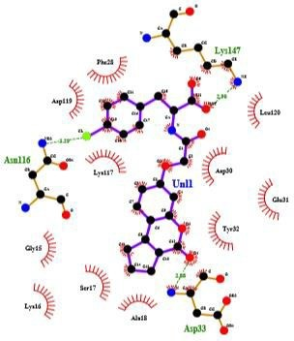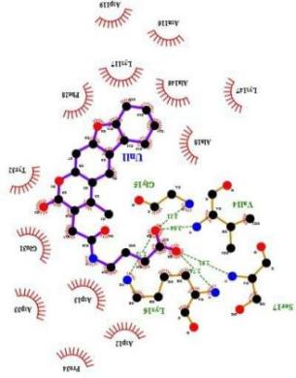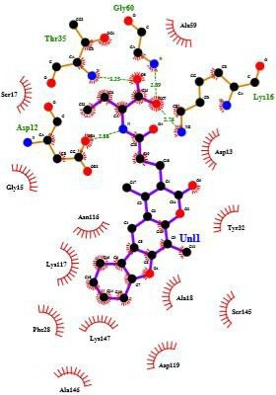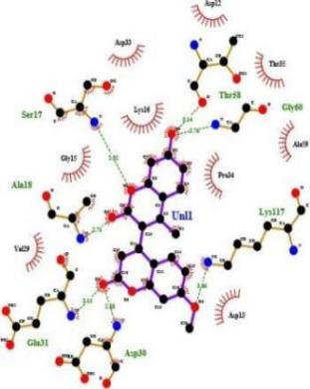
(ZINC02107288) (ZINC02096813) (ZINC02096815) (ZINC02114326)

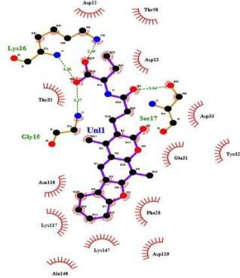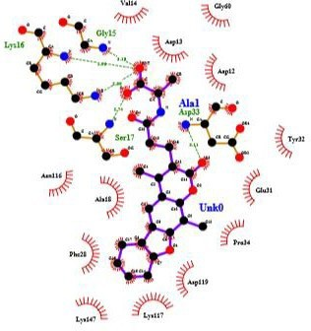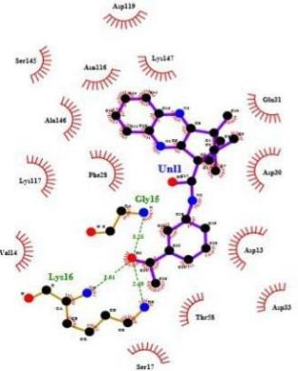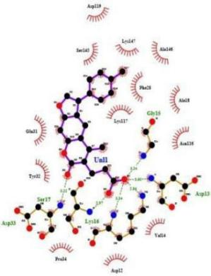
(ZINC01020381) (ZINC06167356) (ZINC02120343) (ZINC02102162)

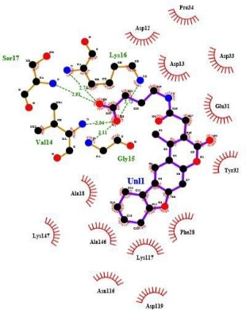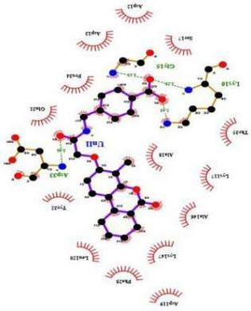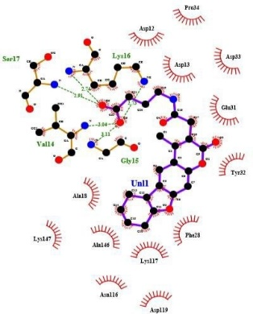
(ZINC02114643) (ZINC00518885) (ZINC03882094)

Figure 2. Two-dimensional interaction diagrams of the top eleven NRAS ligand complexes generated using LigPlot+. Hydrogen bonds are represented as dashed green lines, while hydrophobic contacts are illustrated as red semicircular arcs. The diagrams highlight conserved and mutant residue interactions within the nucleotide-binding pocket, demonstrating consistent engagement of P-loop and switch-region residues.

Current therapeutic strategies for NRAS mutant melanoma primarily rely on downstream MEK inhibition (Johnson & Puzanov, 2015). However, clinical responses to MEK inhibitors such as binimetinib have demonstrated modest improvements in progression-free survival (Ascierto et al., 2013). The structural challenges seen in RAS family proteins have historically been considered “undruggable” due to their high affinity for GTP/GDP and the absence of deep hydrophobic pockets (Cox et al., 2014; McCormick, 2015). Direct NRAS targeting, as explored in this study, may therefore complement or enhance these approaches by addressing the root cause. Natural products account for a substantial proportion of approved anticancer drugs (Newman & Cragg, 2020). Their structural diversity and evolutionary optimisation enable interactions with challenging protein surfaces (Harvey et al., 2015). Our results suggest that natural compounds, with diverse scaffolds and biocompatibility, may offer new chemical starting points to a strategic target in finding novel inhibitors for mutant NRAS. The diversity observed among the top-ranked compounds in this study further underscores the chemical richness of natural product libraries and their suitability for challenging oncogenic targets such as NRAS. Our analysis highlights the importance of conserved residues, which are known to stabilise switch I/II regions and coordinate nucleotide binding. The observation that these residues consistently contributed to ligand stabilisation agrees with prior crystal and biochemical studies on RAS proteins. Although NRAS lacks the reactive cysteine exploited in KRAS G12C (Ostrem et al., 2013). inhibitors, these breakthroughs provide conceptual validation that mutation-specific pockets can be therapeutically elevated. Furthermore, accumulating evidence suggests that allosteric modulation of RAS proteins may represent a viable alternative to direct nucleotide competitive inhibition (Maurer et al., 2012; Welsch et al., 2017). The interaction patterns observed in our analysis, particularly near the switch I and switch II regions, are consistent with previously described transient pockets that regulate effector binding. Nonetheless, the findings presented here are limited by their computational nature. Docking captures a static snapshot of protein-ligand interactions and does not fully address conformational flexibility. (Kitchen et al., 2004). Future studies incorporating molecular dynamics simulations and free energy calculations would strengthen our understanding of the structural details and energetics of the system that can further enhance the binding predictions (Ferreira et al., 2015). Later experimental validation through biochemical assays and melanoma cell models will be necessary to validate our predictions. Collectively, this study contributes to the expanding efforts aimed at overcoming the challenges associated with direct NRAS inhibition by integrating natural product diversity with structure-based virtual screening.

4. CONCLUSION

This study integrates structural modelling, virtual screening and docking to identify potential inhibitors of oncogenic NRAS variants. The mutant models built exhibited high stereochemical quality, enabling reliable analyses. Screening 5,322 natural compounds yielded three guided candidates, namely ZINC02096813, ZINC02120343, and ZINC00518885. They followed strong binding affinities between conserved catalytic residues and mutant sites. These findings suggest that mutation-induced structural plasticity within NRAS can be strategically exploited for inhibitor development. These results being the initial steps towards finding a novel inhibitor, they provide a foundation for further molecular dynamics simulations and experimental validation towards therapies for NRAS-driven melanoma.

Acknowledgements

The authors gratefully acknowledge Dr. Rohan Meshram from Savitribai Phule Pune University for his invaluable guidance and support throughout the study.

Conflict of Interest

The authors declare that they have no conflicts of interest.

Table 1. Docking results of top-ranking ZINC compounds (binding free energy ≤ –10 kcal/mol), highlighting predicted hydrogen bond donor–acceptor pairs and residues involved in hydrophobic or van der Waals interactions.

Figure 1. (A) Protein showing secondary structure elements and residue connectivity. (B) Cartoon representation of the protein and coloured by secondary structure type. (C) Overall model quality plot in PROSA indicating global Z-scores (D) Local quality assessment plot showing per-residue score fluctuations. (E) Ramachandran plot presenting backbone dihedral angle distributions, with most residues occupying favoured regions. (F) Summary of model statistics obtained from the Ramachandran plot.

Figure 2. Two-dimensional interaction diagrams of the top eleven NRAS ligand complexes generated using LigPlot+. Hydrogen bonds are represented as dashed green lines, while hydrophobic contacts are illustrated as red semicircular arcs. The diagrams highlight conserved and mutant residue interactions within the nucleotide-binding pocket, demonstrating consistent engagement of P-loop and switch-region residues.

REFERENCES

Al Mahi, A., & Ablain, J. (2022). RAS pathway regulation in melanoma. Disease Models & Mechanisms, 15(2), dmm049229. https://doi.org/10.1242/dmm.049229

Ardito, C. M., Grüner, B. M., Takeuchi, K. K., Lubeseder-Martellato, C., Teichmann, N., Mazur, P. K., DelGiorno, K. E., Carpenter, E. S., Halbrook, C. J., Hall, J. C., et al. (2012). EGF receptor is required for KRAS-induced pancreatic tumorigenesis. Cancer Cell, 22(3), 304–317. https://doi.org/10.1016/j.ccr.2012.07.024

Ascierto, P. A., Schadendorf, D., Berking, C., Agarwala, S. S., van Herpen, C. M., Queirolo, P., Blank, C. U., Hauschild, A., Beck, J. T., St-Pierre, A., et al. (2013). MEK162 for patients with advanced melanoma harbouring NRAS or BRAF mutations: A non-randomised, open-label phase 2 study. The Lancet Oncology, 14(3), 249–256. https://doi.org/10.1016/S1470-2045(13)70024-X

Başar, Y., Yenigün, S., Gül, F., Özen, T., Demirtaş, İ., Alma, M. H., & Temel, S. (2024). Phytochemical profiling, molecular docking and ADMET prediction of crude extract of Atriplex nitens Schkuhr for the screening of antioxidant and urease inhibitory activity. International Journal of Chemistry and Technology, 8(1), 60–68. https://doi.org/10.32571/ijct.1389719

Cancer Genome Atlas Network. (2015). Genomic classification of cutaneous melanoma. Cell, 161(7), 1681–1696. https://doi.org/10.1016/j.cell.2015.05.044

Cancer.Net Editorial Board. (2025). Melanoma: Stages. American Society of Clinical Oncology. https://www.cancer.net

Cherfils, J., & Zeghouf, M. (2013). Regulation of small GTPases by GEFs, GAPs, and GDIs. Physiological Reviews, 93(1), 269–309. https://doi.org/10.1152/physrev.00003.2012

Cox, A. D., Fesik, S. W., Kimmelman, A. C., Luo, J., & Der, C. J. (2014). Drugging the undruggable RAS: Mission possible? Nature Reviews Drug Discovery, 13(11), 828–851. https://doi.org/10.1038/nrd4389

Dallakyan, S., & Olson, A. J. (2015). Small-molecule library screening by docking with PyRx. Methods in Molecular Biology, 1263, 243–250. https://doi.org/10.1007/978-1-4939-2269-7_19

Ferreira, L. G., Dos Santos, R. N., Oliva, G., & Andricopulo, A. D. (2015). Molecular docking and structure-based drug design strategies. Molecules, 20(7), 13384–13421. https://doi.org/10.3390/molecules200713384

Harvey, A. L., Edrada-Ebel, R., & Quinn, R. J. (2015). The re-emergence of natural products for drug discovery in the genomics era. Nature Reviews Drug Discovery, 14, 111–129. https://doi.org/10.1038/nrd4510

Howe, L. R., Leevers, S. J., Gómez, N., Nakielny, S., Cohen, P., & Marshall, C. J. (1992). Activation of the MAP kinase pathway by the protein kinase Raf. Cell, 71(2), 335–342. https://doi.org/10.1016/0092-8674(92)90362-3

Hu, Z., & Martí, J. (2025). Atomic-level mechanisms of abnormal activation in NRAS oncogenes from two-dimensional free energy landscapes. Nanoscale, 17, 1–12. https://doi.org/10.1039/D4NR03372H

Irwin, J. J., & Shoichet, B. K. (2005). ZINC — A free database of commercially available compounds for virtual screening. Journal of Chemical Information and Modeling, 45(1), 177–182. https://doi.org/10.1021/ci049714+

Johnson, C. W., Reid, D., Parker, J. A., Harrison, R. A., Weston, L., Peti, W., et al. (2017). The small GTPases K-Ras, N-Ras, and H-Ras have distinct biochemical properties determined by allosteric effects. Journal of Biological Chemistry, 292(31), 12981–12993. https://doi.org/10.1074/jbc.M117.778886

Johnson, D. B., & Puzanov, I. (2015). Treatment of NRAS-mutant melanoma. Current Treatment Options in Oncology, 16(4), 15. https://doi.org/10.1007/s11864-015-0330-z

Kanehisa, M., & Goto, S. (2000). KEGG: Kyoto encyclopedia of genes and genomes. Nucleic Acids Research, 28(1), 27–30. https://doi.org/10.1093/nar/28.1.27

Kitchen, D. B., Decornez, H., Furr, J. R., & Bajorath, J. (2004). Docking and scoring in virtual screening for drug discovery. Nature Reviews Drug Discovery, 3(11), 935–949. https://doi.org/10.1038/nrd1549

Kolch, W., Berta, D., & Rosta, E. (2023). Molecular mechanisms of RAF kinase regulation. Biochemical Journal, 480(1), 1–23. https://doi.org/10.1042/BCJ20220547

Lagorce, D., Bouslama, L., Becot, J., Ménard, P., & Villoutreix, B. O. (2017). FAF-Drugs4: Free ADME-tox filtering computations for chemical biology and early stages drug discovery. Bioinformatics, 33(22), 3658–3660. https://doi.org/10.1093/bioinformatics/btx491

Laskowski, R. A., MacArthur, M. W., Moss, D. S., & Thornton, J. M. (1993). PROCHECK: A program to check the stereochemical quality of protein structures. Journal of Applied Crystallography, 26, 283–291. https://doi.org/10.1107/S0021889892009944

Laskowski, R. A., & Swindells, M. B. (2011). LigPlot+: Multiple ligand–protein interaction diagrams for drug discovery. Journal of Chemical Information and Modeling, 51(10), 2778–2786. https://doi.org/10.1021/ci200227u

Li, G., & Zhang, X. C. (2004). GTP hydrolysis mechanism of Ras-like GTPases. Journal of Molecular Biology, 340(5), 921–932. https://doi.org/10.1016/j.jmb.2004.05.079

Li, S., Balmain, A., & Counter, C. M. (2018). A model for RAS mutation patterns in cancers: Finding the sweet spot. Nature Reviews Cancer, 18(12), 767–777. https://doi.org/10.1038/s41568-018-0076-6

Maurer, T., Garrenton, L. S., Oh, A., Pitts, K., Anderson, D. J., Skelton, N. J., Fauber, B. P., Pan, B., Malek, S., Stokoe, D., et al. (2012). Small-molecule ligands bind to a distinct pocket in Ras and inhibit SOS-mediated nucleotide exchange activity. Proceedings of the National Academy of Sciences USA, 109(14), 5299–5304. https://doi.org/10.1073/pnas.1116510109

McCormick, F. (2015). KRAS as a therapeutic target. Clinical Cancer Research, 21(8), 1797–1801. https://doi.org/10.1158/1078-0432.CCR-14-2662

Moore, A. R., Rosenberg, S. C., McCormick, F., & Malek, S. (2020). RAS-targeted therapies: Is the undruggable drugged? Nature Reviews Drug Discovery, 19(8), 533–552. https://doi.org/10.1038/s41573-020-0068-6

Morris, G. M., Huey, R., Lindstrom, W., Sanner, M. F., Belew, R. K., Goodsell, D. S., & Olson, A. J. (2009). AutoDock4 and AutoDockTools4: Automated docking with selective receptor flexibility. Journal of Computational Chemistry, 30(16), 2785–2791. https://doi.org/10.1002/jcc.21256

National Cancer Institute. (2025). The Cancer Genome Atlas Program. https://www.cancer.gov

Navas, C., Hernández-Porras, I., Schuhmacher, A. J., Sibilia, M., Guerra, C., & Barbacid, M. (2012). EGF receptor signaling is essential for K-Ras oncogene-driven pancreatic ductal adenocarcinoma. Cancer Cell, 22(3), 318–330. https://doi.org/10.1016/j.ccr.2012.07.024

Newman, D. J., & Cragg, G. M. (2020). Natural products as sources of new drugs over nearly four decades. Journal of Natural Products, 83(3), 770–803. https://doi.org/10.1021/acs.jnatprod.9b01285

Normanno, N., Tejpar, S., Morgillo, F., De Luca, A., Van Cutsem, E., & Ciardiello, F. (2009). Implications for KRAS status and EGFR-targeted therapies in metastatic colorectal cancer. Nature Reviews Clinical Oncology, 6(9), 519–527. https://doi.org/10.1038/nrclinonc.2009.111

Ostrem, J. M., & Shokat, K. M. (2016). Direct small-molecule inhibitors of KRAS: From structural insights to mechanism-based design. Nature Reviews Drug Discovery, 15(11), 771–785. https://doi.org/10.1038/nrd.2016.139

Pylayeva-Gupta, Y., Grabocka, E., & Bar-Sagi, D. (2011). RAS oncogenes: Weaving a tumorigenic web. Nature Reviews Cancer, 11(11), 761–774. https://doi.org/10.1038/nrc3106

Rodriguez-Viciana, P., Warne, P. H., Dhand, R., Vanhaesebroeck, B., Gout, I., Fry, M. J., Waterfield, M. D., & Downward, J. (1994). Phosphatidylinositol-3-OH kinase as a direct target of Ras. Nature, 370(6490), 527–532. https://doi.org/10.1038/370527a0

Spoerner, M., Hozsa, C., Poetzl, J. A., Reiss, K., Ganser, P., Geyer, M., & Kalbitzer, H. R. (2010). Conformational states of human Ras protein complexed with GTP. Journal of Biological Chemistry, 285(51), 39768–39778. https://doi.org/10.1074/jbc.M110.145235

Vetter, I. R., & Wittinghofer, A. (2001). The guanine nucleotide-binding switch in three dimensions. Science, 294(5545), 1299–1304. https://doi.org/10.1126/science.1062023

Wellbrock, C., & Arozarena, I. (2016). The complexity of the ERK/MAP-kinase pathway and the treatment of melanoma skin cancer. Frontiers in Cell and Developmental Biology, 4, 33. https://doi.org/10.3389/fcell.2016.00033

Welsch, M. E., Kaplan, A., Chambers, J. M., Stokes, M. E., Bos, P. H., Zask, A., Zhang, Y., Sanchez-Martin, M., Badgley, M. A., Huang, C. S., et al. (2017). Multivalent small-molecule pan-RAS inhibitors. Cell, 168(5), 878–889. https://doi.org/10.1016/j.cell.2017.02.006

Wiederstein, M., & Sippl, M. J. (2007). ProSA-web: Interactive web service for the recognition of errors in three-dimensional structures of proteins. Nucleic Acids Research, 35(Web Server issue), W407–W410. https://doi.org/10.1093/nar/gkm290

Wood, K. W., Sarnecki, C., Roberts, T. M., & Blenis, J. (1992). Ras mediates nerve growth factor receptor modulation of three signal-transducing kinases. Cell, 68(6), 1041–1050. https://doi.org/10.1016/0092-8674(92)90072-8

